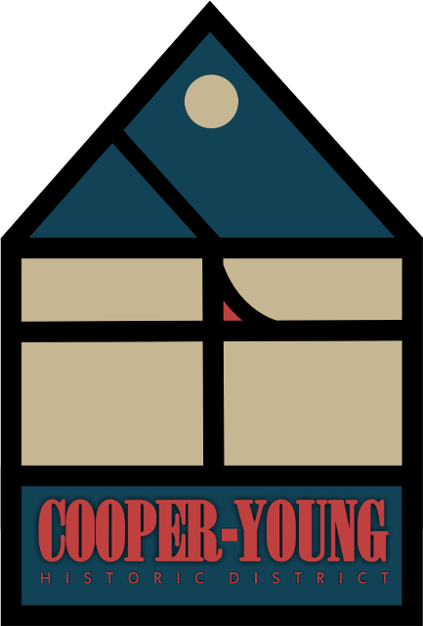

Cooper Young Historic District
Arboretum

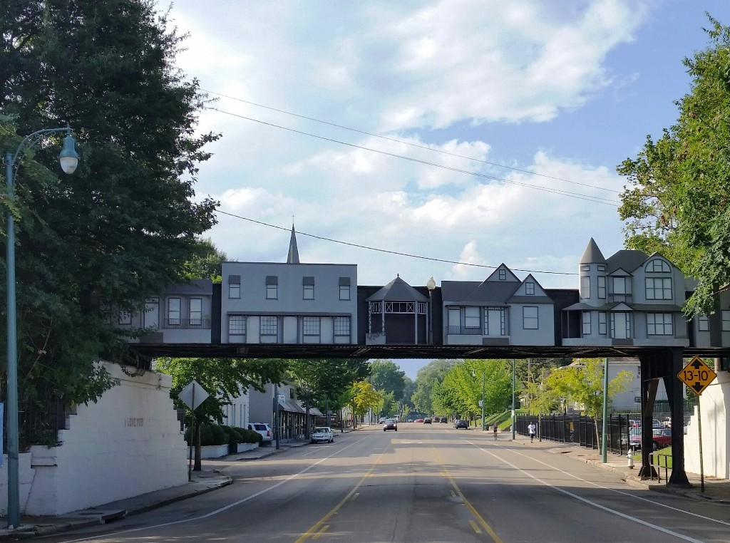

From the moment you enter the Cooper Young Historic District under the art railroad trestle, ginkgo lined Cooper Street greets you. Welcome to the “hippest” neighborhood in midtown Memphis. Quaint homes, restaurants, bars, small retail shops, businesses, and a brewery await you.

The Cooper Young Historic District comprises almost 60 blocks and is home to over 8,000 residents. The majority of homes were developed from the 1890’s to 1940’s. Queen Ann, Victorian, Foursquare, Colonial Cottage, and Craftsman Bungalows all represent the diversity of home styles in this charming neighborhood.

The Cooper Young Arboretum project was created by the Cooper Young Garden Club to encourage community involvement within our own urban forest. Our arboretum encompasses trees located in the front yards of homes, the Spanish American War Park, local businesses, and schools within our neighborhood. Our plan was to bring this arboretum to our neighborhood streets where residents and visitors walk, exercise, shop, dine, and socialize. Our desire is to add to our already magnificent canopy of trees, beautify our neighborhood, improve our air quality, and teach our children to love the beauty of nature.

We are living in a tree museum.

The Cooper Young Arboretum is supported by the Cooper Young Garden Club and the Cooper Young Community Association. Residents and businesses have agreed to maintain and care for their trees listed in the arboretum.
The Cooper Young Garden Club sponsors a yearly tree fund reimbursement program to add to our neighborhood canopy of trees and additional tree species. Additional information about this program is provided at the end of this website.

The Cooper Young Arboretum is free and open to the public daily. Pamphlets with a map may be found at the Cooper Young Community Association office at 2298 Young Avenue or viewed online at www.cooperyoung.org .

Information about the Cooper Young Historic District may be found at the following websites.
www.cooperyoung.org
www.cooperyounggardenclub.org
www.cooperyoung.com
http://tufc.com/arboreta.html

Facebook Pages:
www.facebook.com/groups/CYArboretum
www.facebook.com/groups/CYgardenclub
www.facebook.com/CooperYoungGardenTour

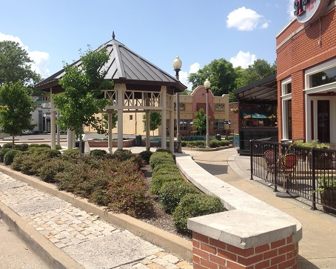
The gazebo surrounded by ginkgo trees at the intersection of Cooper Street and Young Avenue.

Tours may be self-guided with the pamphlet and map or free tours of the neighborhood arboretum can be arranged by calling the Cooper Young Community Association office at 901-272-2922. For help on the walking tour, look for stenciled leaves on the sidewalk. The leaves will match you to the specific tree.

Tours will be conducted by members of the Cooper Young Garden Club.
Kim Halyak
Judi Shellabarger
Katie McHaney

Visitors to the arboretum can expect to see a wide variety of trees. We have huge very old trees to those newly planted to view. We have a diverse number of conifers, oaks, and maples.
We have also included smaller trees/shrubs with mature growth less than 15 feet for added interest.

Cooper-Young Arboretum
Latin Name | Common Name | Address
Acer buergerianum | Trident Maple | 1968 Oliver
Acer tataricum subsp. ginnala | Amur Maple | 1979 Oliver
Acer negundo | Box Elder | 2099 Young
Acer palmatum 'Sango Kaku' | Coral Bark Maple | 1021 Blythe
Acer rubrum | Red Maple | 2256 Evelyn
Acer saccharinum | Silver Maple | 2027 Walker
Acer saccharum | Sugar Maple | 1034 Blythe
Aesculus parviflora | Bottlebrush Buckeye | 897 S. Cox
Albizia julibrissin | Mimosa | 2045 Evelyn
Amelanchier arborea | Downy Serviceberry | 1846 Nelson
Amelanchier xgrandiflora | Apple Serviceberry | 2103 Nelson & Spanish American War Park
Asimina triloba | Common Pawpaw | 2085 Elzey
Betula nigra | River Birch | 2093 Young
Broussonetia papyrifera | Paper Mulberry | 1062 Rembert
Calocedrus decurrens | California Incensecedar | 2052 Nelson
Carpinus caroliniana | American Hornbeam | Spanish American War Park
Carpinus betulus | European Hornbeam | 1035 Blythe
Carya illinoinensis | Pecan | 1859 Young & Peabody Elementary
Castanea mollissima | Chinese Chestnut | 876 Meda
Catalpa bignonioides | Southern Catalpa | 1824 Oliver
Cedrus deodara | Deodar Cedar | 1831 Oliver
Cedrus libani 'Pendula' | Cedar of Lebanon | 2274 Nelson
Celtis occidentalis | Common Hackberry | 993 S. Cooper Stone Soup lot
Cercidiphyllum japonicum | Katsuratree | 2093 Young
Cercis canadensis | Eastern Redbud | 2083 Young
Chamaecyparis thyoides | Atlantic Whitecedar | 1915 Oliver
Chionanthus retusus | Chinese Fringetree | 1980 Nelson & 2216 Nelson
Cladrastis kentukea | American Yellowwood | 2103 Nelson
Cornus asperifolia | Roughleaf Dogwood | Spanish American War Park
Cornus florida | Common Dogwood | 2104 Nelson
Cornus florida 'Cherokee Chief' | Flowering Dogwood | 1979 Oliver
Cornus florida 'Cherokee Brave' | Flowering Dogwood | Spanish American War Park
Cornus kousa | Kousa Dogwood | 1969 Nelson
Cornus x rutgersensis 'Celestial Shadow' | Flowering Dogwood | Spanish American War Park
Cotinus obovatus | American Smoketree | 1915 Elzey & 1888 Walker
Cryptomeria japonica | Japanese Cryptomeria | 1042 Blythe
Cupressus sempervirens | Italian Cypress | 2095 Nelson
xCupressocyparis leylandii | Leyland Cypress | 1073 Blythe
Eucalyptus gunnii | Hardy Silver Gum | 2008 Nelson
Eucommia ulmoides | Hardy Rubber Tree | 862 South Cooper
Ficus carica | Common Fig | 1846 Nelson
Firmiana simplex | Chinese Parasol Tree | 1032 New York
Fraxinus americana | White Ash | 2120 Young lot & 1930 Nelson
Fraxinus pennsylvanica | Green Ash | 2007 Nelson
Ginkgo biloba | Ginkgo | 2053 Oliver
Halesia carolina | Carolina Silverbell | 1991 Oliver
Ilex 'Nellie R. Stevens' | Nellie R. Stevens Holly | 1064 Blythe
Ilex opaca | American Holly | 2244 Nelson
Ilex vomitoria 'Pendula' | Weeping Yaupon | 2160 Elzey
Juglans nigra | Black Walnut | 1915 Nelson
Juniperus chinensis | Chinese Juniper | 1960 Oliver
Juniperus virginiana | Eastern Redcedar | lining Southern Avenue
Koelreuteria paniculata | Panicled Goldenraintree | 2046 Nelson
Lagerstroemia (indica x fauriel) 'Natchez' | Natchez Crapemyrtle | 2103 Nelson
Liquidambar styraciflua | American Sweetgum | 2019 Felix
Ligustrum sinense 'Variegatum' | Varigated Chinese Privet | 1979 Felix
Liriodendron tulipifera | Tuliptree | 1859 Walker
Maclura pomifera | Osage-orange | 2033/ 2037 Nelson
Magnolia grandiflora | Southern Magnolia | 1865 Oliver
Magnolia macrophylla | Bigleaf Magnolia | 2043 Nelson
Magnolia virginiana | Sweetbay Magnolia | 2072 Felix
Magnolia xsoulangeana | Saucer Magnolia | 899 Blythe & 1982 Evelyn
Magnolia stellata | Star Magnolia | 1888 Walker
Malus sp. | Apple Tree | 2012 Felix
Morus rubra | Red Mulberry | 2113 Nelson
Osmanthus fragrans | Fragrant Tea Olive | 1979 Oliver
Parrotia persica | Persian Parrotia | 862 South Cooper
Picea pungens | Colorado Spruce | 2240 York
Pinus parviflora | Japanese White Pine | 2196 Nelson
Pinus strobus | Eastern White Pine | 1021 Blythe
Pinus taeda | Loblolly Pine | 900 S. Cox
Pinus virginiana | Virginia Pine | 2196 Nelson
Platanus occidentalis | Sycamore | 1950 Nelson
Populus deltoides | Eastern Cottonwood | 2177 Evelyn
Prunus sp. | Plum Tree | 1915 Nelson
Prunus cerasifera | Cherry Plum | 1858 Young & 923 New York
Prunus laurocerasus | Common Cherrylaurel | 900 S. Cox
Prunus persica 'Elberta' | Elberta Peach | 1846 Nelson
Prunus persica 'Redhaven' | Redhaven Common Peach | 1846 Nelson
Prunus serotina | Black Cherry | 2100 Young
Prunus xyedoensis | Yoshino Cherry | 1988 Young
Punica granatum | Pomegranate | 876 Meda & 2244York
Pyrus calleryana 'Bradford' | Bradford Callery Pear | 2256 Evelyn
Quercus alba | White Oak | 1056 Blythe
Quercus bicolor | Swamp White Oak | 2015 Felix
Quercus hemisphaerica | Laurel Oak | 2053 Nelson
Quercus michauxii | Swamp Chestnut Oak | 2236 Evelyn
Quercus nigra | Water Oak | 1902 Oliver & 1858 Young
Quercus nuttallii | Nuttall Oak | 862 South Cooper
Quercus pagoda | Cherrybark Oak | 805 S. Cox & 2104 Nelson
Quercus palustris | Pin Oak | 2244 Nelson
Quercus phellos | Willow Oak | 2066 Nelson & 2244 York
Quercus virginiana | Live Oak | 2091 Nelson
Rhus typhina | Staghorn Sumac | 897 S. Cox
Robinia pseudoacacia | Black Locust | Spanish American War Park
Salix babylonica | Babylon Weeping Willow | 2100 Young
Taxodium distichum | Common Baldcypress | 935 Tanglewood
Taxodium distichum var. imbricarium | Pondcypress | 1915 Elzey
Thuja occidentalis | Northern White Cedar | 1915 Elzey
Trachycarpus fortunei | Chinese Windmill Palm | 2091 Nelson
Ulmus alta | Winged Elm | 1841Oliver &1893 Oliver
Ulmus americana | American Elm | 2075 Oliver
Ulmus parvifolia | Lacebark Elm | 1882 Walker
Vitex agnus-castus | Chastetree | 2093 Young
Smaller trees of interest:
Ilex cornuta 'Burfordii' | Chinese Holly | 1064 Blythe
Ilex 'Mary Nell' | Mary Nell Holly | 1924 Elzey
Salix caprea 'Pendula' | Weeping Pussy Willow | 2059 Oliver
Thuja occidentalis 'Filiformis' | Weeping Threadleaf Arborvitae | 1924 Elzey
Magnolia liliiflora | Lily Magnolia | 1874 Oliver

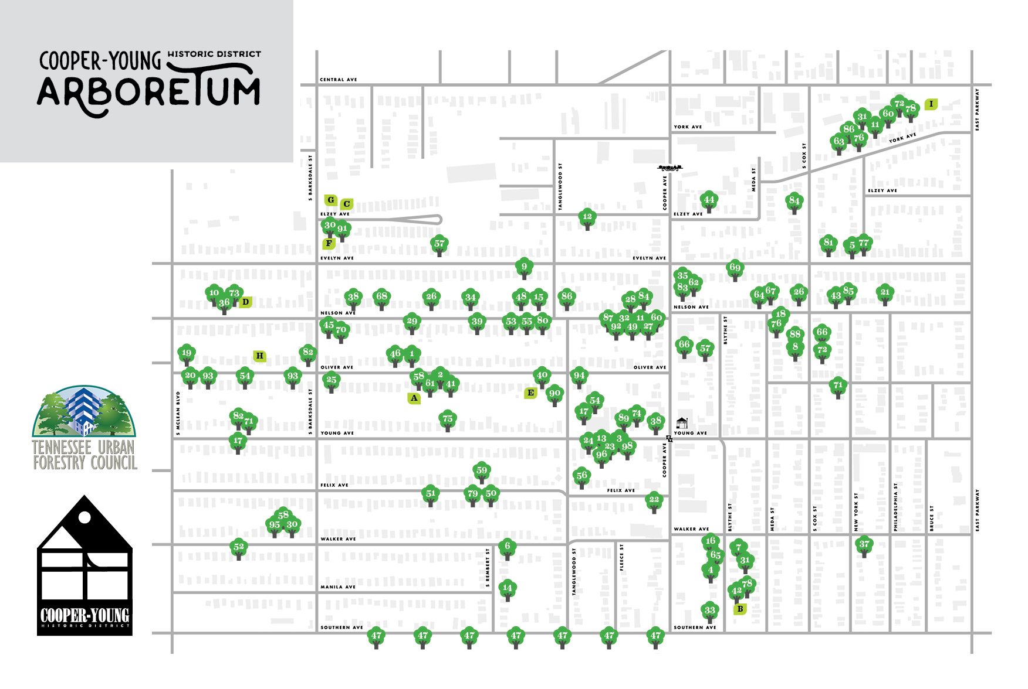

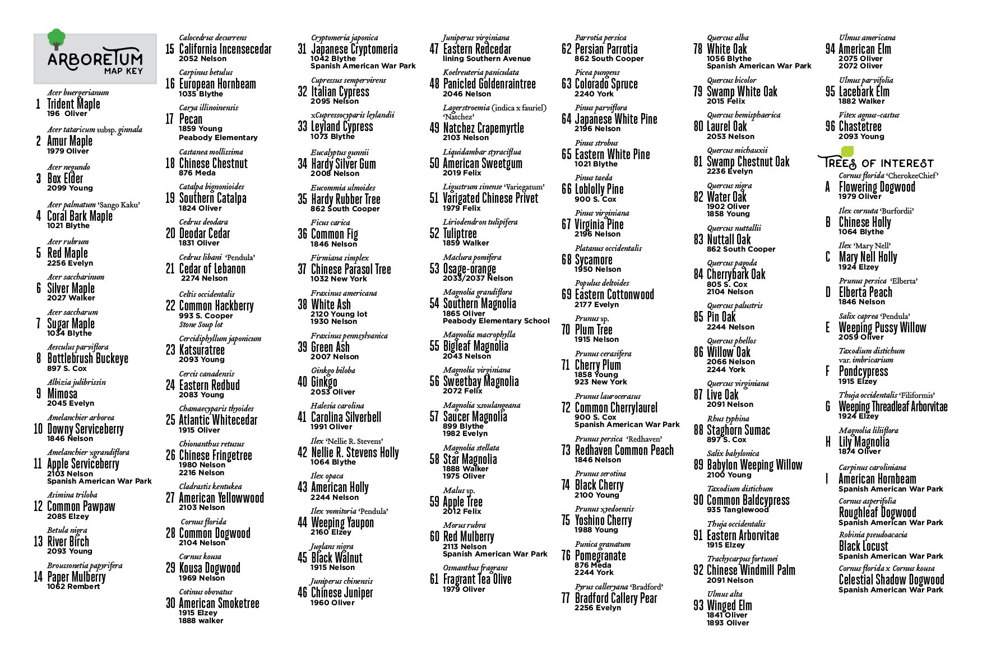

Cooper Young Garden Club Tree Reimbursement Program

The Cooper Young Garden Club sponsors a yearly tree fund reimbursement program to add to our neighborhood canopy of trees and additional tree species. The Cooper Young Garden Club will
reimburse for two trees a year in our neighborhood. The program will be on a first come, first served basis. The CYGC will reimburse for half of the cost of the tree, not to exceed $100.00.

You must meet the following conditions to apply for the tree reimbursement program.
- You must live in the Cooper Young neighborhood.
- Be a member of the Cooper Young Neighborhood Association.
- Choose a tree from the list of appropriate trees and plant in the front yard.
- Provide a receipt to the GYGC.

List of Trees for CYGC reimbursement program:

Oaks
Chinkapin Oak
Southern Red Oak
Northern Red Oak
Shingle Oak
Overcup Oak
Bur Oak
Laurel Oak
Turkey Oak
Shumard Oak
Scarlet Oak

Maples
Trident Maple
Box Elder
Red Maple
Striped Maple
Black Maple

Conifers
Dawn Redwood
Blue Spruce
Silver Korean Fir
Contorted White Pine
Bristlecone Pine
Japanese White Pine
Canadian Hemlock
Deodar Cedar
Atlas Cedar
Weeping Blue Atlas Cedar

Fruit/Berry/Nut
Persimmon
Pawpaw
Plum
Butternut Hickory
Shellbark Hickory
Shagbark Hickory
Apricot
Pear
Elderberry

Other
American Beech
Rusty Blackhaw
Dove Tree
Pussywillow
Sugarberry
American Elm
American Hornbeam
Common Winterberry
Lacebark Elm
Kentucky Coffeetree
Yellowwood
Chinese Chestnut
Osage-Orange
Witchhazel
Downy Serviceberry
Allegany Serviceberry
Littleleaf Linden
Hophornbeam

In creating this arboretum, we also added educational websites for our neighborhood schools and for those students who are home-schooled.

Educational Websites:
www.realtrees4kids.org
www.kidzone.ws/trees/plants
www.pbs.org/parents/adventures-in-learning/2013/10/lets-learn-trees-video
www.plt.org
www.treesaregood.org
www.interactivesites.weebly.com
www.kids.nationalgeographic.com
www.home.howstuffworks.com/trees.htm
www.americanforests.org/why-it-matters
www.nwf.org/garden
www.xerces.org
www.allaboutbirds.org Cornell University Lab of Ornithology
www.arborday.org

